**Maple Glazed Rainbow Carrots**  
__________________________________________________________  
*This recipe makes use of Riverside’s rainbow carrots.*



**Ingredients**

* 2 pounds rainbow carrots, whole
* Salt and pepper to taste
* 2 tablespoons olive oil
* 2 tablespoons unsalted butter, melted
* 4 tablespoons real maple syrup, plus more for drizzling at the end

**Directions**

1. Preheat oven to 425 degrees F.
2. Wash carrots thoroughly, especially between the top and the stem. Peel carrots, leaving part of the stem if desired.
3. Arrange carrots on a large sheet pan. Toss carrots with salt, pepper, and olive oil. Roast for 15 minutes, turning halfway through, until tender.
4. Remove from oven. Toss carrots with maple syrup and melted butter. Return to oven and roast for an additional 5-8 minutes, watching it so that the maple glaze doesn’t burn. Arrange on a serving plate and drizzle some more maple syrup if decided. Enjoy!

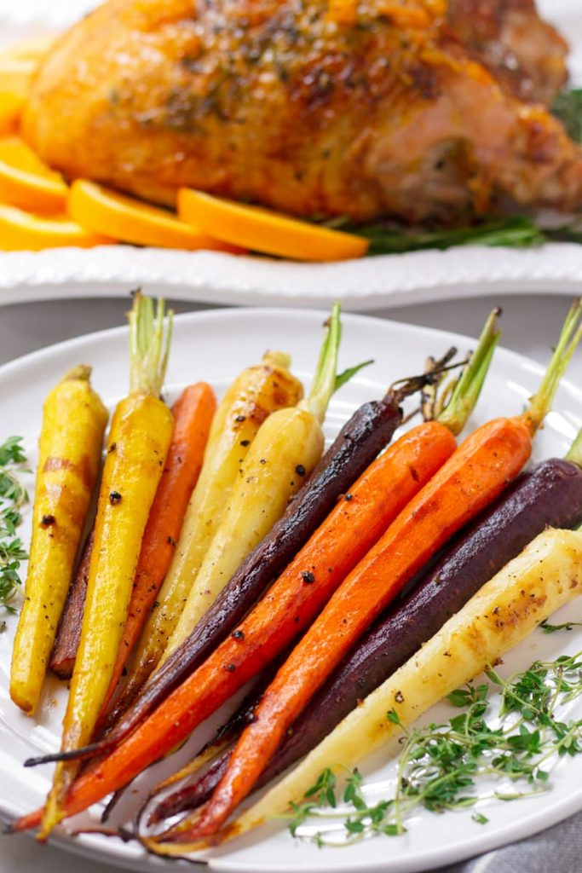

source: [cookingformysoul.com](https://cookingformysoul.com/maple-glazed-rainbow-carrots/)